58152—

**2018**

**( 62660-3:2016)**

**-**

# 3

**(IEC 62660-3:2016, MOD)**

Москва Стандартинформ 2018

58152—2018

1 « » (

« ») ,

4

2 044 « »

3 8

6 2018 . N9 318-

4

62660-3:2016 « - .

3. » (IEC 62660-3:2016 «Secondary lithium-ion cells for the propulsion of electric road vehicles — Part 3: Safety requirements». MOO).

61434

.

, ,

. 3.10

61434 , 2.

6.1 .

6.4.4.2 1.5—2001 ( 4.4.4.4.4.5).

,

,

5

6 .

( )

## *26*

*29 2015 . 162- « ».*

*( 1*

*) « »,*

*— « ».*

*( )*

*». ,*

*—*

*«*

## *(*[*www.gost.nj*](http://www.gost.nj/)*)*

© . . 2018

,

**II**

58152—2018

1 ................................... ............................................................................................................. 1

2 ................................................................................................................. ............................. 1

3 ................................................................................................................... ....................... 2

4 .................................................................................................................. ................................3

4.1 ...................................................................................................................... ....................... 3

4.2 ................................................................................................................... ..........3

4.2.1 ...................................................................................................... 3

4.2.2 ......................................................................................................................... . 3

4.2.3 ........................................................................................................................ ................ 3

4.2.4 ..................................................................................................................... ... 3

4.2.5 ......................................................................................................................... .......... 4

4.3 ..................................................................................................... 4

4.4 ..................................................................................................................... ............ 4

5 .................................................................................................................. ..................... 4

5.1 ...................................................................................................................... ....................... 4

5.2 ..................................................................................................................... .......................................... 4

5.3 ........................................................................................................ ..5

6 ................................................................................................................... .................5

6.1 ...................................................................................................................... ........................ 5

6.2 .................................................................................................... 5

6.2.1 ............................................................................................................................. ...................... 5

6.2.2 .......................................................................................................................... ........5

6.2.3 ......................................................................................................................... ................ 6

6.3 ........................................................................................................................... ................ 7

6.3.1 .................................................................... 7

6.3.2 ........................................................................................... 7

6.4 ................................................................................................................... .......... 7

6.4.1 ............................................................................................................ 7

6.4.2 .............................................................................................................................. ................ 7

6.4.3 .................................................................................................................. ... 8

6.4.4 ............................................................................. 8

( ) ..............................10

8 ( ) ........................... 13

( ) , 61434... .15

( ) *

, *

................................................................................................. 16

........................................................................................................................... ..................................... 17

**III**

58152—2018

- ,

**2**

, — .

, - .

-

,

12405-1 12405-2.

, 62660-1. 62660-2,

,

- , ( ).

, - ,

- 12405-3.

,

, (1).

, ,

.

, ,

, .

, —

- ,

.

( )

. « - »

.

**IV**

# 58152—2018

**( 62660-3:2016)**

-

3

**Secondary bthium- cells for the propulsion *of* electric road vehicles.**

**Part 3. Safety requirements**

**— 2019—03—01**

# 1

- , .

( ) ( ).

**1**

**.**

**2 ( ).**

**.**

.

, .

,

,

, ( ).

.

**1 -**

***12405-3.* -**

**(2]. *62619***

**- ,**

**, .**

**2 .**

# 2

8

.

## *60050-482—2011 .*

**1**

58152—2018

## *62619—2018 .*

*.*

*62660-2—2014 -*

*. 2.*

**—**

**—**

**« », 1 ,**

**« » .**

**, ,**

**. ,**

**,**

**( ). ,**

**, , , ,**

**. ,**

**. , , .**

# 3

60050-482.

:

* 1. **; (battery electric vehicle; BEV): ,**

.

* 1. **(cell block): ,**

, ,

( ), ,

.

,

|  |  |  |  |  |
| --- | --- | --- | --- | --- |
| **3.3**  **,** | **(explosion):** | **,** |  | **,** |
| **3.4** | **(fire):** |  |  |  |
| **3.5** |  |  | **;** | **(hybrid electric vehicle; HEV):** |

.

.

.

, ,

.

* 1. **(internal short circuit):**

.

* 1. **(leakage); ,**

, / , .

* 1. **(nominal voltage): ,**

.

* 1. **(rated capacity); 3. - ,. -**

. .

* 1. **. /,(reference test current. /,): , .**

. .

**1 ( . .**

**2**

* 1. **(room temperature); (25 ± 2) °C.**
  2. **(rupture): ,**

, ,

.

**2**

58152—2018

* 1. **- , (secondary lithium-ion cell, ceil):**

, /

.

**1 ,**

**, . ,**

**, , , .**

**2 « » « - »,**

**.**

* 1. **; (state of charge. SOC): ,**

.

* 1. **(venting):**

, .

# 4

4.1

.

, ,

. .

4.2

4.2.1

.

, , .

, ,

.

.

4.2.2

4.2.3

,

1 / .

, 0,5 .

4.2.4

, ,

## *4.3'.* **,**

.

.

1.

, .

**\* . 4.2.1.**

**3**

58152—2018

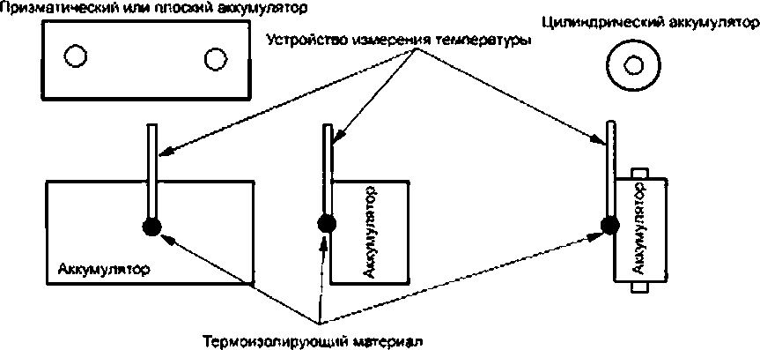

**1 —**

4.2.5

4.3

,

, , 4.3.

, :

a) ± 0.1 % ;

b) ± 1 % ;

c) ± 2 * ;

d) ± 0.1 % ;

e) ± 0.1 % ;

f) ± 0.1 % .

,

4.4

,

**.**

12 . ,

. , 1 .

1 * .

,

.

# 5

5.1

, ,

, .

1/3 /, ( )

1 /, ( ) , .

, .

5.2

5.3. ,

.

**4**

58152—2018

1 — 5.1.

2 — 1/3 /, ( )

4.4.

3 —

5.3

1 /, ( ) , .

/(( ) . . 3.9.

. - , .

. —

.

1 — 5.1.

2 — 4.4.

3 — 1/3 /, ( ) 1 /, ( )

{100- )/100 * (100 - )/100 1

. . %, .

# 6

6.1

**: .**

**.**

**.**

**.**

**. .**

**.**

**75 ' .**

, ,

, ,

.

,

.

.

.

{ )

.

1 .

.

6.2

6.2.1

6.2.1.1

6.2.1.2

6.2.1.3

,

.

.

## *62660-2—2014 ( 6.1.1.1).*

, ,

. .

6.2.2

6.2.2.1

**5**

58152—2018

.

.2.2.2

6.2.2.3

. .

6.2.3

6.2.3.1

**, >**

,

*62660-2-—2014* **( 6.1.2.1).**

, ,

,

, .

6.2.3.2

.

a) 100 % 80 %

5.3.

b)

,

150 . ,

, , .

,

6 / .

c) ,

**.**

, 2.

15 %

1000 , ,

. 24 ,

80 % ,

.

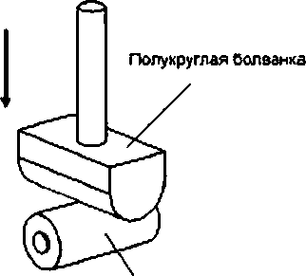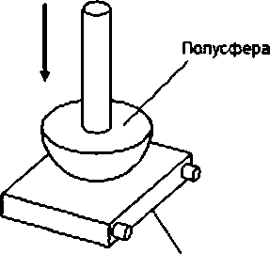

**» —**

) )

**2 —**

**6**

58152—2018

6.2.3.3

.

6.3

6.3.1

6.3.1.1

,

.

.

6.3.1.2

.

a) 100 % 80 %

5.3.

* + 1. **, ,**

.

5 ' / (130 ± 2) .

6.3.1.3

6.3.2

6.3.2.1

30 . , , ,

1 .

**— , .**

**, .**

.

,

. .

6.3.2.2

6.3.2.3

. .

6.4

*62660-2—2014* **( 6.2.2.1.1).**

, ,

, ,

, .

6.4.1

6.4.1.1

,

.

6.4.1.2

*62660-2—2014* **( 6.3.1.1).**

6.4.1.3

8 .

6.4.2

6.4.2.1

,

.

6.4.2.2

.

**7**

58152—2018

a) 100 % 5.3.

b) 100 % 1 /,( )

5 /, ( )

, .

, 120 % ,

, ,

130 % . , .

6.4.2.3

.

6.4.3

6.4.3.1

,

.

6.4.3.2

.

a) 0 % 5.3.

b) 0 % 1 /, ( ) .

,

25 % , ,

30 . , .

6.4.3.3

, ,

. .

6.4.4

6.4.4.1

,

. .

.

**—**

**.**

6.4.4.2

)

## *62619—2018.*

b) 7.3.2. .

,

. ,

, , ,

.

. .

{ , ) . S

,

.

**1 , ,**

**.**

**2 ,**

**,**

***( )***

**. ,**

**8**

58152—2018

**, , .**

**FMEA . . .**

b)

,

, ,

, .

1)

.

.

2)

( ).

3) ,

*62619—2018,* **) 7.3.2.**

4) .

6.4.4.2, ).

**5) ( .** *62619—2018. 1).*

, .

, . .

, ,

,

, 6.4.4.3 .

6.4.4.2. ),

, .

**1 ,**

**.**

**2 (3].**

c)

8 , ,

, ( . . ,

), ,

,

.

## *62619.*

**—**

***12405-3.***

6.4.4.3

8 .

**9**

58152—2018

**( )**

**.1**

**,**

**. ,**

**, .**

**, .**

**,**

**.**

**, ,**

**.**

**.2**

**AJ.1**

**,**

**, .**

**. (**

**) , .**

**,**

**. . ,**

**.**

**.**

**,**

**, , , ,**

**, 120 % .**

**.**

**.2.2**

**,**

**. , ,**

**. , , ,**

**— ( . . ).**

**, ,**

**. , ,**

**, , . ,**

**, .**

**, , , :**

**• ,**

**:**

**• ,**

**, :**

* + - * **, , ,**

**, 6**

**.**

**AJ.3**

**.2.3.1**

**10**

58152—2018

**.**

**. ,**

**,**

**, . ,**

**,**

**/ .**

**.2.3.2**

**, ,**

**-**

**. , , , ,**

**.**

**:**

**• ,**

**, , ;**

* **, ,**

**.**

**.2.3.3**

**,**

**. ,**

**.**

**. ,**

**. ,**

**,**

**, .**

**,**

**:**

**• ,**

**, ,**

**:**

**• ,**

**.**

**.**

**. 1 . *,***

***",* ,**

**, / .**

**, .1.**

**. .2 .**

**\* ( ,**

**)**

**.**

**11**

58152—2018

**v ••••»•• •**

**.............**

**2**

**( )**

**[**

*2*

|  |  |  |  |  |
| --- | --- | --- | --- | --- |
| **<......** | | | |  |
| **. .......** | |  |  |
|  | |  | **J** |
|  | **2** | **( )**  **fc** | **5•**  **2** 1 |  |

**, 2 3 „ &**

**( )**

**, ~ Tj — . 2 - — ;**

**- —**

**— -**

**2**

**( )**

**1**

**1**

**•**

**1**

**•**

**•**

**I**

I

**1**

**• 1**

X

**• 1**

1

**8**

**X**

**i**

**1**

**•**

**i**

**1**

**i**

**2**t

**(**

**)**

» , <

**( )**

**, ~ 2 - . 2 « - ;**

**- T4 -**

**.2 — -**

**12**

58152—2018

**( )**

**.1**

**. 6.4.4.2. ),**

**8**

**. ,**

**. 8 6.4.4.2.**

**).**

**.**

**,**

**. , ,**

**( , ,**

**). ,**

**: .**

**- .**

**.2 ,**

**.**

**6.4.4**

**,**

**—**

**( . .1).**

**. ,**

**- .**

**.1 —**

|  |  |  |  |
| --- | --- | --- | --- |
|  |  |  |  |
|  |  |  | **6.3.1** |
|  | **6.2.1** |
| **( )** | **6.2.2** |
|  | **6.2.3** |
|  | **(**  **)** |  | **_ 8** |
|  | **6.4.2** |
|  | **6.4.3** |
| **-**  **/** | **—** |
|  |  |  | **6.4.4** |
|  | **_** |
|  | **_** |
| **6.4.4**  **, , - .** | | | |

**6.4.4,2. ),**

**(FISC). *62619.* FISC**

***62133* [4]. FISC ,**

**.**

**13**

58152—2018

**,**

**, .**

**,**

**FISC. ,**

**.**

**.**

**1**

**- ,**

**.**

**.**

**.**

**2**

**, .**

**, ,**

**.**

**14**

58152—2018

**( )**

, 61434

**, — . * .**

**,**

**- . . , ( . ) . (5] ,**

**.**

**/,( ) [5] .**

**, ,**

**:**

**/, = 1**

***—* , . ;**

***—* , , ,**

**.**

**/,.**

**. , ,**

**. , - 5, ,**

**, 0,2 /, . = 1. ,**

**, 1.0 /( .**

**. , /,. /,**

***„* .**

**15**

58152—2018

**( )**

,

**.1**

|  |  |  |
| --- | --- | --- |
| **\*** |  |  |
| **60050-482—2011** | **IDT** | **IEC 60050-4822004 «**  **. 482.**  **»** |
| **62619—2018** | **IDT** | **IEC 62619:2017 «**  **.**  **.**  **»** |
| **62660-2—2014** | **IDT** | **IEC 62660-2:2010 « -**  **. 2.**  **»** |
| **—**  **:**   * **IDT — .** | | |

**16**

58152—2018

**[1]**

**( ) N9100**

**(UN Regulation No.100**

**{UN R! 00)]**

**[2] 0 18243**

**{ISO 18243)**

**[3]**

**62660-4**

**{IEC/TR 62660-4)**

**[4]**

**62914**

**{IEC/TR 62914)**

**.**

**(02 )**

**Uniform provisions concerning the approval of vehicles with regard to specific re quirements for the electric power train (02 series of amendment or later)**

**.**

**-**

**Electrically propelled mopeds and motorcycles — Test specification and safely re quirements for lithKim-ion battery system**

**-**

**. 4.**

**62660-3**

**Secondary lithium-ion cells for the propulsion of electric road vehicles — Candidate alternative test methods for the internal short circuit test of IEC 62660-3**

**,**

**.**

**62133—2012**

**Secondary cells and batteries containing alkaline or other non-acid electro lytes— Experimental procedure for the forced internal short-circuit test of IEC 621332012**

**[5] 61434 ,**

**.**

**{IEC 61434)**

**Secondary cells and batteries containing alkaline or other non-acid electro**

**lytes — Guide to the designation of current in afcaline secondary cel and battery standards**

**17**

58152—2018

621.355.9:006.354 29.220.99.43.120 2 27.20.23.130

621.331 27.20.23.130

: - , ,

**18**

**5—2018/24**

***. .***

***. .***

***. .***

***. .***

**08.06-2016 16.06.2016. 60*64’/j. .**

**. . . 2.76. .- . . 2,51**

**,**

**« »**

**. 123001 . .,**

**www postmfo ru** [**inlo@gos1infd.ru**](mailto:inlo@gos1infd.ru)