,

( )

INTERSTATE COUNCIL FOR STANDARDIZATION, METROLOGY AND CERTIFICATION (ISC,

**IEC 61340-4-1—**

**2017**

**ЭЛЕКТРОСТАТИКА**

**Методы испытаний для прикладных задач**

ЭЛЕКТРИЧЕСКОЕ СОПРОТИВЛЕНИЕ НАПОЛЬНЫХ ПОКРЫТИЙ И УСТАНОВЛЕННЫХ ПОЛОВ

# (IEC 61340-4-1:2015, Electrostatics — Part 4-1: Standard test methods for specific applications — Electrical resistance of floor coverings and installed floors, IDT)

М о скв а Стандартимформ 2018

IEC 61340-4-1—2017

,

1.0—2015 « .

» 1.2—2015 « .

. . ,

. »

1 « -

» ( « ») « - « »

, 5

2

3 ,

( 30 2017 . No 52)

:

|  |  |  |
| --- | --- | --- |
| **( 3166) 004-97** | **( 3166) 004-97** |  |
|  | **AM** |  |
| **BY** |
| **KG** |
| **RU** |
| **UZ** |
| **UA** |

4 26

2016 . No 431- IEC 61340-4-1—2017

1 2018 .

5 IEC 61340-4-1:2015 «

. 4-1. .

» («Electrostatics — Part 4-1: Standard test methods for specific applications — Electrical resistance of floor coverings and installed floors», IDT).

IEC/TC 101

«Electrostatics».

1.5 ( 3.6).

,

6

## « », —

*« ». ( )*

*« ». ,*

*—*

[*(www.gost.ru*](http://www.gost.ru/)*)*

© , . 2018

.

**II**

IEC 61340-4.1—2017

1 ........................................................................................................................ ...................... 1

2 ....................................................................................................................... ..................... 1

3 ................................................................................................................... ......................1

4 ................................................................................................................. ................... 2

5 ........................................................................................................................ ............................................ 2

6 .............................................................................................. 5

7 ........................................................................................................ 5

8 ................................................................................................... 5

9 ................................................................................................................. .............................. 5

10 ............................................................... 7

11 ..................................................................................................................... ........................ 7 ( )

............................................................................................ 8

**III**

\AV

# IEC 61340-4-1—2017

**Electrostatics. Part 4-1. Test methods for specific applications. Electrical resistance of floor coverings and installed floors**

**—2018—08—01**

# 1

,

**, 104 10’3 .**

, ,

.

.

**— ,**

**,**

**,**

**.**

# 2

8 (

, —

( )]:

ISO 1957:2000, Machine-made textile floor coverings — Selection and cutting of specimens for physical tests ( .

)

# 3

8 :

.

|  |  |  |
| --- | --- | --- |
| **3.1** | **(acceptance testing):** | **,** |
| **3.2** | **(geometric mean):** |  |
| ***- -*** | ***■*** |  |
| **3.3**  **.**  **3.4** | **(groundable point):**  **(insulating material):**  **10 .** | **,** |

.

**1**

IEC 61540-4-1—2017

* 1. **(laboratory evaluations): ,**

.

* 1. **(resistance to ground): ,**

, ,

.

* 1. **(point-to-point resistance): ,**

, .

3.6 (vertical resistance): ,

,

.

# 4

.

.

,

, .

.

# 5

5.1

( )

±10 %, .

5.1.1

:

- (10 ± 0.5) — 1 * 106 ;

* **(100 ± 5) — 1 10* 1 * 1011 ;**

> (500 ± 25) 8 — 1 * 10” .

.

, ,

.

5.1.2

:

«(10 ± 0.5) — 1 * 6 ;

- (100 ± 5) — 1 » 106 1 * 10” :

- (500 ± 25} 8 — 1 10” .

.

. ,

.

.

5.2

**2**

(

) , -

IEC 61340-4*1—2017

. 1.

(65 ± 5) . , , *

,

(60 ± 10) . , *

, *

( . 5.3}. 1000 .

, , , *

.

. :

a) (2.5 ± 0,25) — , ;

b) (5.0 ± 0,25) — , .

**— 1014**

**( . 1).**

5.3

(600110} 1 ( ) , *

.

5.4

( . 6) , *

.

( . 6).

**, 1 * 1014 .**

.

, ,

.

5.5

,

(640110) (5 ± 1) .

**1 * 1014 .**

(5 ± 1) .

**1 ’4 .**

, (1300 ± 10) * (600 1 10) *

,

**3**

IEC 61340-4-1—2017

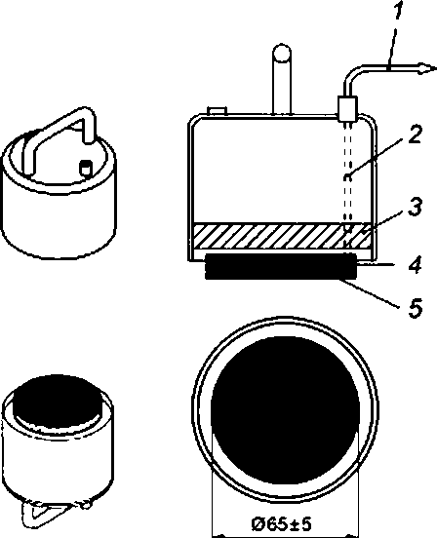

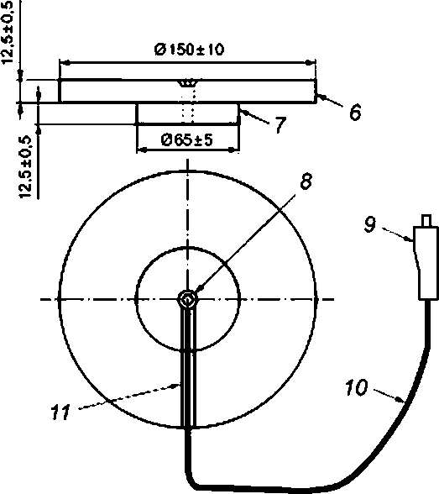

**: (2.5±0,25) (5.0 ± 0,25) .**

**1 — ; *2* — , ;**

***3 —* ; 4 — : 5 — ;**

**— , ,**

**, S.2. ), 6.2. ); 7 — : —**

**: 9 — . 10 — , — {**

**)**

**1 —**

**4**

IEC 61340-4-1—2017

# 6

ISO 1957.

ISO 1957 ,

.

(500 1 50) .

{1200 ± 50) * (500 ± 50} .

, ,

, — , .

.

,

.

,

.

, .

. . ( . 5.4) ,

. ,

.

,

, (1000 150) ( . 9.4).

,

.

.

# 7

.

.

.

# 8

, : (23 ± 2) " .

(12 ± 3} %. — 46 .

24 (20 ± 2) *

(65 ± 3) %.

, .

,

,

.

# 9

9.1

-

. , (

2 95 %). , .

**5**

IEC 61340-4-1—2017

**—**

**.**

9.2

, -

(5.5). (5.2)

, (300 ± 10) . -

,

, .

, .

, .

, (5.1).

10 . (15 ± 2)

. 10 .

100 . 1.0 * 1011 . 500

. ,

, 5.1. :

a) 10 8 1.0 * 10 . 100 1.0 * 10* ;

b) 100 1.0 * 1011 . 500 1.0 * 11 .

, .

,

100 .

, . . ,

, , .

.

, .

9.3 ( )

(5.3) (5.5).

.

(5.2) ,

100 . ,

, .

,

(5.2). 10 . (15 1 2)

. 10* . 100

. 1.0 * 1011 . 500

. ,

, 5.1. :

a) 10 8 1.0 * 10 . 100 1,0 * 10 ;

b) 100 1.0 * 1011 . 500 1,0 * 1011 .

, .

.

100 .

9.4

(5.5). (5.2)

,

100 . ,

,

.

IEC 61340- —2017

,

(5.1). 10 . (15 ± 2)

. 10 .

100 . 1.0 * 11 .

500 . ,

, 5.1,

:

a) 10 1.0 * 10 . 100 1,0 * 10 :

b) 100 1,0 * 10” . 500 1.0 * 10” .

, .

.

(1000 ± 50) .

100 .

. ,

, ,

,

(1000 ± 50) .

,

,

**100 2 .**

# 10

. , ,

.

# 11

:

1. **:**
2. **, :**
3. **;**

d) ,

. :

- :

, ;

- :

;

e) .

0 ;

) , ,

;

h) , ;

i) : , ,

:

1. **, ;**
2. **;**
3. **;**

) , ,

, , , .

**7**

IEC 61340-4-1—2017

**( }**

**.1**

|  |  |  |
| --- | --- | --- |
|  |  |  |
| **ISO 1957:2000** | **—** | **•** |
| **\* .**  **.**  **.** | | |

677.076:006.354 17.220.99 IDT

59.080.60

: , , ,

**. ,**

**2—2018/33**

***. .***

***. .***

***. .***

***. .***

**27.07.2018. 31.07.2018. 60*84’/^. .**

**. . . 1.40. .- . . 1.26.**

**,**

**« »**

**. 123001 . .. 4.**

[**www.gostinro.ru**](http://www.gostinro.ru/) [**info@gostinfo.ru**](mailto:info@gostinfo.ru)